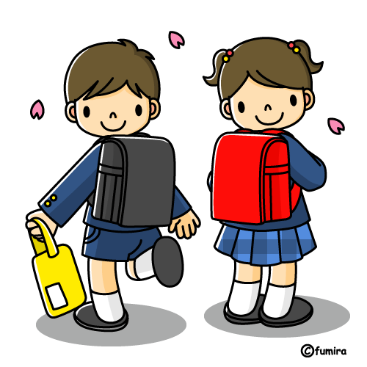
Elementary School and Junior High School Games
*Due to space restrictions, this is just a list of the most popular games used in class.
Goal: To support listening to, speaking, and reading English. Some are warm-ups and some are full games.
ELEMENTARY SCHOOL:
Name of Game: | Notes:
Keyword Game
Missing Game
What’s this? (3 types)
Slap Game/ Fly Swatter Game
Janken Game
Karuta
Lucky Card Game
Bingo
Maze Games
Jeopardy
Fruits Basket
JUNIOR HIGH SCHOOL:
Name of Game: | Notes:
Castle Game
Row Game
Hangman
Last Sentence Dictation

Tips:  -Other ways to encourage students: songs, cheers, dancing.  -Consider the time a game takes and class size.  -Assess what the students already know.  -Prepare all necessary materials | Resources:  -Tools for Educators (www.toolsforeducators.com) Make your own resources  -MES-English (www.mes-english.com) Lots of resources available to use and activity lists.  -JHS Englipedia Project (http://jhsenglipediaproject.com) Many ALT made activities by textbook and chapter  -Englipedia (http://www.englipedia.net/Pages/default.aspx)  -Genki English (http://genkienglish.net/teaching/games/) A website made by an ALT.

