110  To report a crime to the police. | 119  To report a fire, call for an ambulance, or to call for rescue service.
03 -5774 -0992  Tokyo English Lifeline | 050 -5534 -5566  AJET Peer Support Group
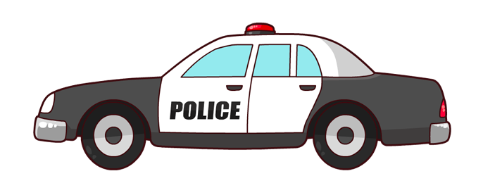
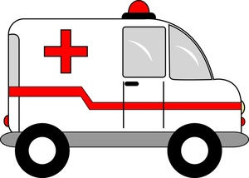
While Japan is considered safe, both Japanese and foreign women still experience threatening behavior. Try to stay aware of your surroundings and use common sense.

It is important to know that women who have been harassed and attacked in Kumamoto did nothing to provoke this treatment. Sometimes these incidents were random, and sometimes female ALTs were targeted simply because they are highly visible young women.

Through the lens of Japanese culture, however, some innocuous actions may be interpreted as inappropriate or provocative. Be aware that certain behaviors (such as running in shorts and a tank top, showing cleavage, being physically affectionate, walking home alone late at night, etc.) may cause suspicion to be directed at the victim instead of their aggressor.

Emergency Numbers
Safety in Kumamoto

Sexual Harassment:

In cases of sexual harassment in the workplace, your supervisor at the BOE is who you should technically go to first. However, it's understandable that you may feel more comfortable talking to a PA in English about it first. You can contact the PAs at kumamotopa@gmail.com.

Emergency vocabulary:

Yamete kudasai - Stop it

Tasukete kudasai – Help me

Kyukyusha o yonde kudasai - Please call an ambulance

Chikan – Groper

Keisatsukan – Police station

General Safety Tips:

- Always lock your house, whether you are going out or are at home. Do not write your name on your mailbox.
- Be selective about giving out personal information such as Facebook or Line IDs
- If walking alone at night cannot be avoided, bring a flashlight with you and do not listen to music or play with your phone. Text a friend to let them know when you're leaving and check in when you're back home.
- Watch your purse, especially in crowded places like nightclubs. Wallet thefts DO happen.
- Always keep an eye on your drink when out at bars or clubs.
- In smaller towns especially, sometimes wearing clothes that seem perfectly modest at home can be interpreted as showing off too much skin and attract unwanted attention. Having your knees, shoulders, and cleavage covered is generally considered "modest" here.
- If you think you are being followed, go to a convenience store or a police box and ask for help.
- Invest in a portable cell phone charger, so you're never caught with a dead battery.
- Vary your route home, if possible. As ALTs we stand out and are easily noticed.
- Make sure you know how you’re getting home. Public transit ends earlier than in other countries, so make sure you know the last train or bus time. Additionally, make sure you have enough money for an emergency cab, as ATMs also shut down for the night.
- Enter an emergency contact in your cell phone in Japanese and English.

